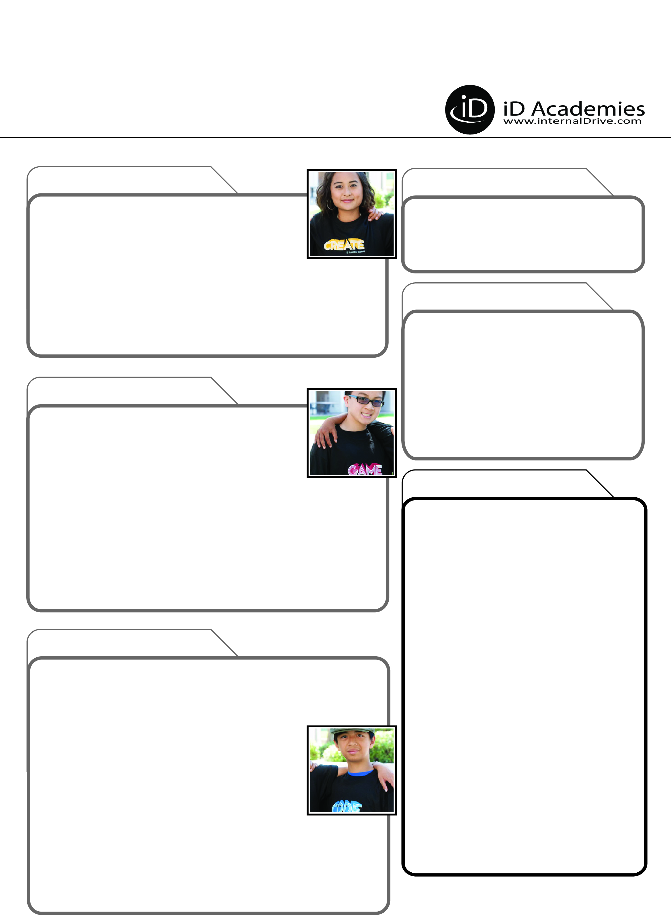­

**Before Heading Home: Test Your Project!**

Your take-home folder will contain your USB Drive with your project files. Remember to verify you have what you need before leaving.

**Academy Photos**

Go to *www.internalDrive.com/TheBasement* to find Academy Photos posted as early as Tuesday.

**Guest Speakers (Subject to Change)**

**TYPE NAME OF SPEAKER & COMPANY/FILM**

**Tours (Subject to Change)**

**TYPE NAME OF COMPANY/STUDIO**

**HEALTH & MEDICATION**

**PHOTOS & EVENTS**

**LAUNCH PARTY**

*We cordially invite iD family and friends to help us celebrate our students’ accomplishments at the Launch Party…visit our labs, meet the staff, view completed projects, and participate in the Graduation Ceremony!*

**The 2nd Friday of the Session, 3 PM\***

**Check-Out: By 4 PM**

*We suggest arriving 15 minutes early for parking.

**Where to Go:**

Our computer labs are located in ______________

in the ________________Building. We’ll meet you _____________. You should park in _____. Cost to park is ____.

**AFTER THE ACADEMY**

**CONTACT NUMBERS**

**AT THE ACADEMY**

Thank you!

**Updates - Your Responsibility**

Please communicate any changes to your student's health since the last time you filled out your Required

Forms and check in any medications with iD Staff.

**Pick-Up & Drop-Off Location for Non-Weekend Students:**

**_______TYPE LOCATION ON CAMPUS HERE__________**

**Pick-Up & Drop-Off Time Frames:**

|  |  |
| --- | --- |
| 1st Friday Pick-Up  *(If Not Enrolled in Weekend Stays)* | 3:30 PM - 4 PM |
| Sunday Check-in for 2nd Week  *(If Not Enrolled in Weekend Stays)* | **6 PM** |
| Final Friday Launch Party & Check-Out | **See Info to Right 🡺** |

IMPORTANT PROGRAM INFORMATION

**Director Name: _____TYPE DIRECTOR NAME HERE_____**

**Director Cell Phone: ___DIRECTOR CELL NUMBER HERE_**

**Program Advisors: 1-888-709-TECH (8324), option 1.**

If you have any feedback, questions or concerns about your experience,

we want to hear from you.

**Please note:** The Director’s cell is operational only during camp hours.

During busy check-in & check-out times, please phone the main office

at **1-888-709-TECH (8324), option 1.**

**Return for Another Session This Summer. Save $50!**

Continue exploring the same course or try a new one.  Check availability at *www.internalDrive.com/locations* or call 1-888-709-TECH (8324).

You will automatically receive a $50 Multi-Week discount.

Also, if you return with a friend who is new to iD,

you can both save $50 through our Refer-a-Friend program.

**Keep Learning From Home with *iD Tech 365***

Thousands of iD students keep learning year-round with

iD Tech 365. Why not you? Learn from fun, engaging

tech tutorials, compete in gaming tournaments and stay

connected through community forums.

*Subscribe at www.iDTech365.com*

**Check out our Free eBooks on STEM Careers**

Our free eBooks provide 10 Steps to Becoming a Professional Game Designer,

App Developer, Animator, Robotics Engineer, Filmmaker, and more.

*www.internalDrive.com/eBooks*